Document-Based Essay for the Great Depression and WWII

In an analytical, formal essay that has a thesis and uses primary and secondary sources that we have read, and information from our lectures as evidence, address the following prompt:

Look at the image below. It was commissioned by the United States Works Progress Administration and placed in the Pittsburg Post Office and Courthouse (remember Pittsburg was the site of Andrew Carnegie’s steel factories in the Gilded Age). The image was meant to portray a strong and healthy American culture and economy. In fact, Franklin Roosevelt’s administration funded the creation of such propagandistic art all over the country to send the message that America, thanks to the help of the federal government, would be strong and safe once again following the Great Depression.

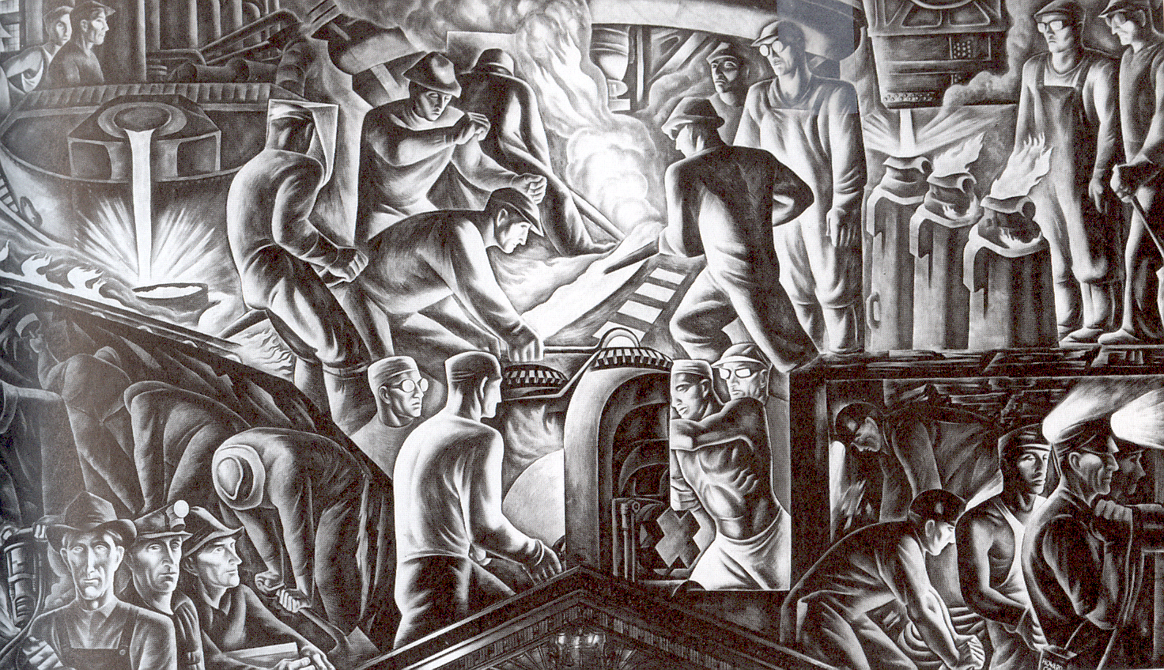

In your essay for this week, evaluate whether or not the actions of the federal government during the New Deal and WWII increased the strength and safety of the county. You MUST focus on at least 3 of our themes (immigration, economics/labor, civil rights race/women, environment/natural resources), but you could likely focus on all 4 themes.

Page 1 of 2

The essay should be 6 pages long and must include Chicago Style footnotes .

Sources you could use as support for your argument are:

The Plow that Broke the Plains (film)
The primary sources about the GM Strike
Lecture information on the FLSA (Fair Labor Standards Act) and the NLRA (National Labor Relations Act) and the Social Security Act.
Rosie the Riveter interviews
Lecture and research information on FEPC (Fair Employment Practices Commission)
Lecture information about the first New Deal policies – especially the Works Progress Administration and the Civilian Conservation Corps (WPA and CCC)
Executive Order 9066
Internment experience documents
ALL the photographs and art from the WWII lecture
Information about immigration and the deportation and Bracero policies toward Mexican immigrants
FDR’s Boulder Dam Dedication and information about dam building from lecture
Lecture information and readings from Navajo miners about the creation of the atomic bomb

You may use our digital textbook as well but you should not use outside sources.

Page 2 of 2

